|  |
| --- |
| Name: Group-A  Group number -72 |
| Student Reference Number: |



|  |  |  |
| --- | --- | --- |
| Module Code: PUSL2021 | Module Name: Computing Group Project | |
| Coursework Title: Weather forecast Application. | | |
| Deadline Date: 25 October 2023 | | Member of staff responsible for coursework: Pelaketiyage Pelaketiya - 10898591 |
| Programme: BSc(Honours) Software Engineering Plymouth University | | |
| Please note that University Academic Regulations are available under Rules and Regulations on the University website [www.plymouth.ac.uk/studenthandbook](http://www.plymouth.ac.uk/studenthandbook). | | |
| Group work: please list all names of all participants formally associated with this work and state whether the work was undertaken alone or as part of a team. Please note you may be required to identify individual responsibility for component parts.   |  |  |  | | --- | --- | --- | | Index number | Name | Responsibility | | 10898591 | Pelaketiyage Pelaketiya | Project and group leader | | 10899564 | Keerthi Jayarathna | Planning leader | | 10825555 | Thisura Yapa | Technical leader | | 10898445 | Sivasammugam Dharshan | Programming leader | | 10898505 | Gamladdalage Jayawardhana | Quality leader | | 10899569 | Harigam Jayathilake | Testing and maintenance leader |   ***We confirm that we have read and understood the Plymouth University regulations relating to Assessment Offences and that we are aware of the possible penalties for any breach of these regulations. We confirm that this is the independent work of the group.***  Signed on behalf of the group: Anuja | | |
| Individual assignment: ***I confirm that I have read and understood the Plymouth University regulations relating to Assessment Offences and that I am aware of the possible penalties for any breach of these regulations. I confirm that this is my own independent work.***  Signed : | | |
| Use of translation software: failure to declare that translation software or a similar writing aid has been used will be treated as an assessment offence.  I not used translation software. | | |
| **Overall mark _____% Assessors Initials ______ Date_________** | | |

*Please delete as appropriateSci/ps/d:/students/cwkfrontcover/2013/14

**Accurate weather**

**Introduction**

Another advantage of this application is that users can get weather forecast from their location or from any other location by specifying any desired location based on a map in this application. Also, another advantage of this application is that weather reports can be obtained at any place for 10 days from the day we live. With this accurate information users can confidently plan and plan not only their day-to-day activities but also the next 10 days.

Using this weather application is not only limited to weather data. That is, tourists can also get information about the weather of their destination using this application and have the ability to prepare for it. Also, as another example, the cultivators pointed out that this application helps as another aspect. Can be given. This application is useful for carrying out their daily farming and this application helps the fishermen to do their fishing activities on that day. Also, this application sends weather warnings as text messages to the user's information as an instant message.

Finally, weather apps have become a user-friendly tool for various purposes. Also, when you want to check your daily activities, monitor the weather data and weather warnings needed to plan a travel vacation, this application will undoubtedly help you in your daily life in detail.

**Objects**,

* Accurate weather information

Our main goal is to provide accurate and current weather details to our user.

* Users friendly interface

Our application is designed using attractive and very simple interfaces.

* Location awareness

Automatically fetches user's current location and provides relevant weather information.

* Customization

Users can personalize the app's color, location and number of days to display the weather as per their preference.

* Weather maps

Our app contains a World map. It allows you to get weather information anywhere in the world.

* Alerts and Notifications

This gives you a notification about the weather conditions at your location.

**Targets,**

* General users

People looking for weather information can make decisions about their upcoming activities or trips by knowing the weather in their desired area and the weather in the coming days.

* Travelers

People organizing travel for business or outdoor activities often need accurate weather forecasts. By using our application, they can perform those activities very easily.

* Pilots and Mariners

Pilots and sailors can get the weather information they need to safely carry out their operations.

* Event Planners

Event planners can get the weather information they need for their upcoming outdoor events.

Features,

* 10 – Day forecast
* Severe weather information
* Next-hour precipitation
* Air quality
* Data Source
* Maps
* SMS Text alert

Time spent on Project (Gantt Chart)

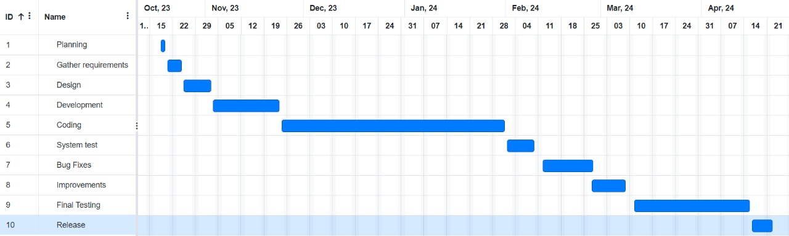

**Budget for Project**

|  |  |  |  |
| --- | --- | --- | --- |
|  | Description | Qty | Amount RS. |
| O1  02  03 | Development Cost   * Design Software and tools * Database and Management   Operating Costs   * Maintenance and support   (Software Updates, patches)   * API Cost   Testing and Quality Assurance   * Testing tools |  | 1000.00  1000.00  5000.00  1000.00 |
|  | Total |  | 8000.00 |